# **Don Quixote, The Crazy Man**

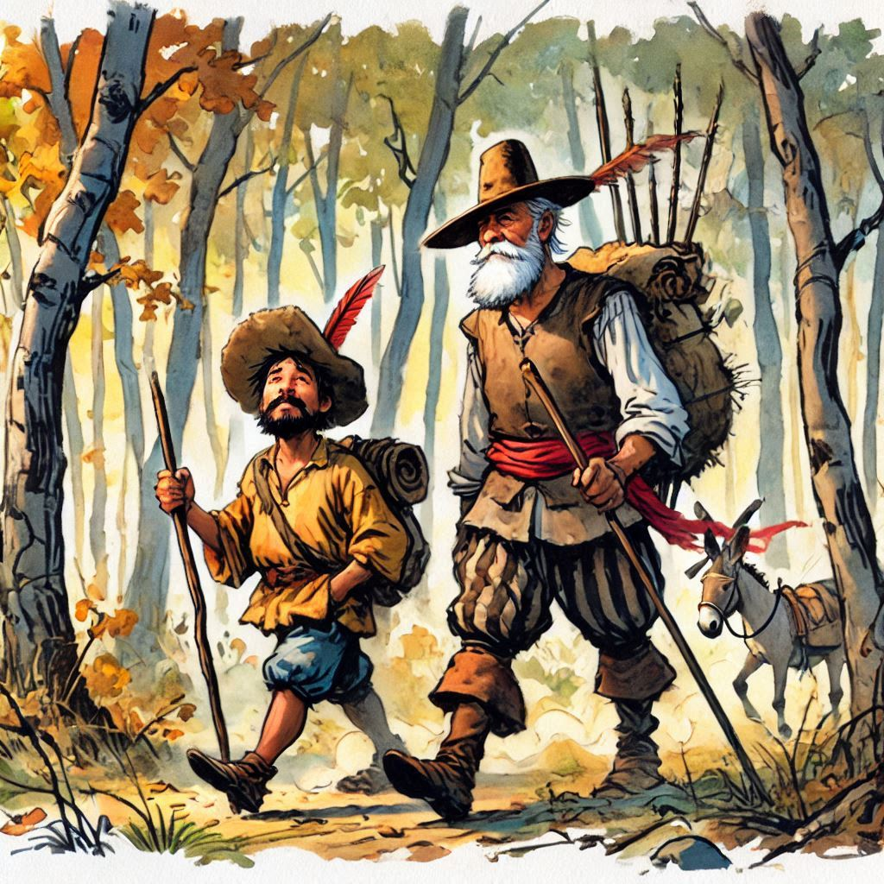

In a village of La Mancha, there lived a peculiar man named Don Quixote, whose madness stemmed from his obsession with chivalric books. One day, a boy named Sancho approached him in the library, and after introducing himself, he joined Don Quixote in reading together. When they said goodbye, Sancho noticed Don Quixote's strange clothing, to which Don Quixote explained that he liked the fashion of the Middle Ages. Later, Don Quixote invited Sancho to take a walk around the village, where he acted as if he were defending his honor against a giant, provoking the villagers to insult him and throw tomatoes. Horrified by the treatment his new friend was receiving, Sancho felt terrible. Don Quixote, sad, sneaked away to a hill to be alone, but Sancho followed him and decided to stay by his side. Don Quixote shared his feelings of discouragement, and Sancho, smiling, told him that while he might not understand everything he believed, he saw the strength in his heart and that he was more than his appearance.  
  
A few days later, Sancho took Don Quixote to a castle and revealed that he was the heir to the throne. On the balcony, he introduced himself as the new king and expressed his disappointment at how they had treated Don Quixote. From that moment on, he named him his loyal advisor and the town's official writer. The villagers, shocked, began to show respect to Don Quixote and apologized to him. This experience transformed the community's perception of Don Quixote, who, with Sancho's support, found a new purpose and recognition in his life.

**Decide if these statements are true / false or the text doesn’t say anything about it.**

1. Don Quixote’s madness was caused by his obsession with books about chivalry.
2. Sancho was a grown man when he first met Don Quixote.
3. Don Quixote preferred clothing inspired by the Middle Ages.
4. Don Quixote liked how Sancho looked.
5. Don Quixote and Sancho firstly met in a library.
6. Don Quixote acted as though he was defending his honor against a giant while walking through the village.
7. The villagers insulted Don Quixote and threw tomatoes at him.
8. Sancho left Don Quixote when he saw how the villagers treated him.
9. Sancho comforted Don Quixote by realizing his strength of heart.
10. Sancho revealed himself to be an heir to the throne and took Don Quixote to a castle.
11. Don Quixote became the town's official writer and loyal advisor to King Sancho.
12. The villagers did not apologize to Don Quixote for how they treated him.
13. The experience changed how the villagers viewed Don Quixote.

**Match the words 1 – 10 to their definitions a - j.**

|  |  |
| --- | --- |
| 1. disappointment 2. madness 3. recognition 4. advisor 5. relieved 6. perception 7. approach 8. purpose 9. obsession 10. horrified | 1. the craziness stemmed - when you are angry or upset 2. sadness or displeasure caused by the non-fulfilment of one's hopes or expectations. 3. when you do or want something very much like books,animals 4. he has shown something could be personality could be a thing 5. a reason 6. terrified/ scared 7. the ability to become aware of something through the senses 8. identification of someone or something 9. to come closer 10. someone is helping you with your decisions |

**Answer these questions.**

1. Who is Don Quixote?
2. Where did Don Quixote live?
3. Where did Sancho take Don Quixote?
4. What kind of fashion did Don Quixote like?
5. Why did the villagers throw tomatoes at Sancho?
6. When and why did the villagers show respect to Don Quixote?
7. Where did Sancho introduce himself as the new king?
8. How does Sancho show his support for Don Quixote?
9. What is Don Quixote's obsession?
10. How and where does Sancho and Don Quixote meet?

**Fill in the gaps.**

1. Boy named __________________approached him in the library
2. Sancho took Don Quixote to a __________and revealed that he was the heir to the throne.
3. Don Quixote was obsessed with _________books.
4. He liked the ________of the Middle Ages.
5. Don Quixote is a book written by ________________in ______.
6. The villagers, shocked, began to show respect to ______ and ______ to him.
7. On the balcony, he introduced himself as ___________________.
8. Provoking the villagers to _______him and ______tomatoes.
9. Don Quixote is still important today because it talks about things like____________and____________.
10. Don Quixote named him his _____ _______ and the town’s official writer.
11. He tries to fight giants, but they are actually just ____________.

**Discuss these topics.**

1. What’s the idea of this story?
2. What would you say was the motto of the story?
3. Have you ever seen someone misjudged because of how they looked or acted?
4. How does the story reflect the importance of standing up for others?
5. How would you treat Don Quixote if you didn’t know he was royal?
6. Have you ever been judged by someone?
7. Have you ever stood up for someone who was being judged?
8. How do you think that one person feels?